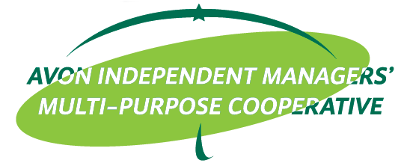

ACTIVITY DESIGN

ACTIVITY : PMES/MOM
LOCATION : Avon ______
DATE/TIME : _____________

OBJECTIVES:
  - To refresh and update AIM-MPC members
  - To recruit new members

PARTICIPANTS:
- ___________________________________

TRAINER/S:
- ___________________________________

BUDGETARY REQUIREMENTS:

Particulars | Budget
Meal for Attendees: Snack P100.00/pax Lunch P175.00
Trainer’s/BCs meal: P100.00/pax (snack)
Trainer’s/BCs meal: P175.00/pax (lunch)
Trainer’s fee (P3,000.00)
BC Allowance (P1,000.00)
Transportation Allowance (back & forth) (trainer only)
Contingency
TOTAL

Prepared by: Recommending Approval:

_____________ JONA MARIE S. PACASUM
EdCom Trainer EdCom Chairperson
Approved by: Noted by:

PERLITA A. BALLETA REYNALDO O. ACOSTA
General Treasurer BOD Chairperson

